Chapter 32-2

binary treeS

Class TNode

//Example 32-2-1
public class TNode<T>
{
public T value;
public TNode<T> left;
public TNode<T> right;
public TNode(T item)
{
value = item;
left = null;
right = null;
}
public TNode(T item, TNode<T> left, TNode<T> right)
{
value = item;
this.left = left;
this.right = right;
}
}

Abstract model: TNode Model:
A
left A right

left B right
left C right
B
C

D
E
F
left D right
left E right
left F right

G
H
left E right

//Example 32-2-2
public class Demo
{
//Builds the tree depicted above.
public static void main(String[] args)
{
TNode<Character> root= buildTree();
}
public static TNode< Character> buildTree()
{
TNode<Character> H= new TNode< Character >('H');
TNode<Character> E= new TNode< Character >('E', null, H);
TNode<Character> F= new TNode< Character >('F');
TNode<Character> C= new TNode< Character >('C', E, F);
TNode<Character> G= new TNode< Character >('G');
TNode<Character> D= new TNode< Character >('D', G, null);
TNode<Character> B= new TNode< Character >('B', null, D);
TNode<Character> A= new TNode< Character >('A', B, C);
return A;
}
}

Binary tree traversal

- There are 4 common scan algorithms which systematically visit every node exactly once in a tree:
  - Preorder: visit root, then left subtree in preorder, then right subtree in preorder

(root) A
(left) > B > D > D
(right) > C > E > H > F

  - Inorder: visit left subtree in inorder, then root, then right subtree in inorder

(left) B > G > D
(root) > A
(left) > E > H > C > F

  - Postorder: visit left subtree in postorder, then right subtree in postorder, then root

(left) G D B
(right) H E F C
(root) A

  - Level order (not recursive): visit nodes level by level from left to right

A
B C
D E F
G H

//Example 32-2-3
import java.util.Queue;
import java.util.LinkedList;
public class BinaryTree
{
//Output: The values of the binary tree rooted by t printed on the screen in preorder
public static <T> void preorderOutput(TNode<T> t)
{
if (t != null)
{
System.out.print (t.value + " ");
preorderOutput(t.left);
preorderOutput(t.right);
}
}

//Output: The values of the binary tree rooted by t printed on the screen in inorder
public static <T> void inorderOutput(TNode<T> t)
{
if (t != null)
{
preorderOutput(t.left);
System.out.print (t.value + " ");
preorderOutput(t.right);
}
}

//Output: The values of the binary tree rooted by t printed on the screen in postorder
public static <T> void postorderOutput(TNode<T> t)
{
if (t != null)
{
preorderOutput(t.left);
preorderOutput(t.right);
System.out.print (t.value + " ");
}

}

//Output: The values of the binary tree rooted by t printed on the screen in levelorder
public static <T> void levelorderOutput(TNode<T> t)
{
if (t == null) return;

Queue<TNode<T>> nodes = new LinkedList<>();
nodes.offer(t);

while (!nodes.isEmpty())
{
TNode node = nodes.poll();
System.out.print(node.value + " ");
if (node.left != null) nodes.offer(node.left);
if (node.right != null) nodes.offer(node.right);
}

}
}

//Example 32-2-4
public class Demo
{
public static void main(String[] args)
{
TNode<Character> root= buildTree();
System.out.print("Preorder: ");
BinaryTree.preorderOutput(root);
System.out.println();
System.out.print("Inorder: ");
BinaryTree.inorderOutput(root);
System.out.println();
System.out.print("Postorder: ");
BinaryTree.postorderOutput (root);
System.out.println();
System.out.print("Levelorder: ");
BinaryTree.levelorderOutput (root);
System.out.println();
}
public static TNode< Character> buildTree()
{
TNode<Character> H= new TNode< Character >('H');
TNode<Character> E= new TNode< Character >('E', null, H);
TNode<Character> F= new TNode< Character >('F');
TNode<Character> C= new TNode< Character >('C', E, F);
TNode<Character> G= new TNode< Character >('G');
TNode<Character> D= new TNode< Character >('D', G, null);
TNode<Character> B= new TNode< Character >('B', null, D);
TNode<Character> A= new TNode< Character >('A', B, C);
return A;
}
}
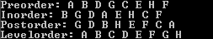

The Visitor interface

//Example 32-2-5
public interface Visitor<T>
{
void visit(T item);
}

Two Visitor classes

//Example 32-2-6
public class OutputVisitor<T> implements Visitor<T>
{
//Ouput: This OutputVisitor object prints a node when it visits a node.
public void visit(T obj)
{
System.out.print(obj + " ");
}
}

//Example 32-2-7
public class FindMaxVisitor<T extends Comparable<? super T>> implements Visitor<T>
{
private T max = null;
//Pre: This FindMaxVisitor object contains the current max among all the nodes it has visited.
//Post: This FindMaxVisitor object updates its max if its max is less than the node it is visiting
public void visit(T obj)
{
if (max == null) max = obj;
else if (obj.compareTo(max) > 0) max = obj;
}
//Return: The current maximum
public T getMax()
{
return max;
}
}

Using the Visitor classes

- Consider the following binary tree:
25

10
37

30
15
65

//Example 32-2-8
public class Demo
{
public static void main(String[] args)
{
TNode<Integer> root = buildTree();
OutputVisitor<Integer> outputVisitorObj = new OutputVisitor<Integer>();
FindMaxVisitor<Integer> findMaxVisitorObj = new FindMaxVisitor<Integer>();
System.out.print("Tree in inorder: ");
inorder(root, outputVisitorObj);
System.out.println();
inorder(root, findMaxVisitorObj);
System.out.println("Max value is " + findMaxVisitorObj.getMax());
}
public static TNode<Integer> buildTree()
{
TNode<Integer> N15= new TNode<Integer>(15);
TNode<Integer> N30= new TNode<Integer>(30);
TNode<Integer> N65= new TNode<Integer>(65);
TNode<Integer> N10= new TNode<Integer>(10, null, N15);
TNode<Integer> N37= new TNode<Integer>(37, N30, N65);
TNode<Integer> N25= new TNode<Integer>(25, N10, N37);
return N25;
}
public static <T> void inorder(TNode<T> t, Visitor<T> v)
{
if (t != null)
{
inorder(t.left, v);
v.visit(t.value);
inorder(t.right, v);
}
}
}
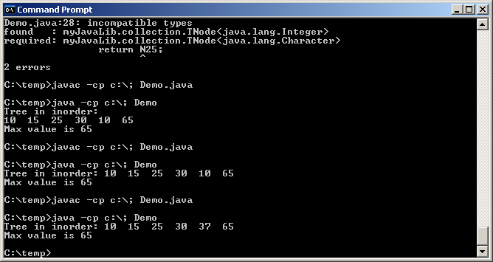

Generalizing the use of Visitor classes

//Example 32-2-9
import java.util.LinkedList;
import java.util.Collection;
import java.util.Iterator;
class Demo
{
public static void main(String[] args)
{
Integer s=null;
LinkedList < Integer > list = new LinkedList < Integer >();
list.add(10);
list.add(20);
list.add(30);
list.add(40);
list.add(25);
OutputVisitor<Integer> outputVisitorObj = new OutputVisitor<Integer>();
FindMaxVisitor<Integer> findMaxVisitorObj = new FindMaxVisitor<Integer>();
System.out.print("List: ");
scan (list, outputVisitorObj);
System.out.println();
scan (list, findMaxVisitorObj);
System.out.println("Max value is " + findMaxVisitorObj.getMax());
}
public static <T> void scan (Collection<T> c, Visitor<T> v)
{
Integer<T> iter = c.iterator();
while (iter.hasNext())
v.visit(iter.next());
}
}
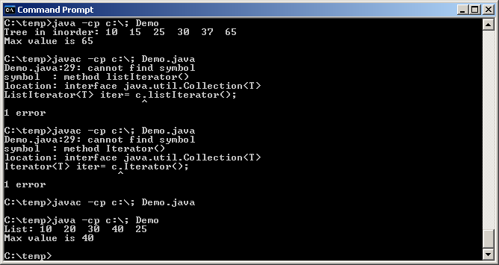

Useful BinaryTree methods

- We will develop some useful binary tree methods and put them in class BinaryTree.
//Desc: Find height of a binary tree
//Pre: t points to a binary tree
//Return:Height of the binary tree pointed to by t (-1 if tree is empty)
// recursive case: height(t) = 1 + max(height(t.left), height(t.right)) when t is not null
// base case: -1 when t is null
public static <T> int height(TNode<T> t)
{
if (t == null) return -1
else return 1 + Math.max(height(t.left), height(t.right));
}
//Desc: Count number of leaf nodes
//Pre: t points to a binary tree
//Return: Number of leaf nodes in binary tree pointed to by t.
// When t is not null: leafCourt(t) = leafCount(t.left) + leafCount(t.right)
// When t is null: leafCount(t) = 0
// When t.left and t.right is null: leafCount(t) = 1
public static <T> int leafCount (TNode<T> t)
{
if (t == null) return 0;
else if ((t.left == null) && (t.right == null)) return 1;
else leafCount(t.left) + leafCount(t.right);

}

//Desc: Make a copy of a binary tree
//Pre: t points to a binary tree
//Return:A binary tree that is an exact copy of the one pointed to by t
public static <T> TNode<T> copyTree(TNode<T> t)
{
if (t == null) return null;

TNode<T> left = copyTree(t.left);
TNode<T> right = copyTree(t.right);
TNode<T> root = new TNode<T>(t.value, left, right);
return root;
}

Deleting a binary tree

// clearing a tree, all you need is t = null
// however, java will only garbage collect level-by-level (because the rest of the tree is pointing to something each pass)
// So if you want to clear it all at once and worry about the garbage collection speed, we must do more.
- First try:
public static <T> void clearTree(TNode<T> t)
{
if (t != null)
{
clearTree(t.left);
clearTree(t.right);
t = null;
}
}
- The above version does not work. The following version does work.
//Desc: Delete all nodes in a binary tree
//Pre: t points to a binary tree
//Post: All nodes in binary tree referenced by t released.
//Note: The caller must assign the return value of clearTree to the root of the binary tree the
// caller is trying to clear
public static <T> TNode<T> clearTree(TNode<T> t)
{
if (t != null)
{
t.left = clearTree (t.left);
t.right = clearTree (t.right);
return null;
}
else return null;
}
  - Add this version of clearTree to class BinaryTree.

Testing class BinaryTree

- We will use the following binary tree to test our class BinaryTree:
25
10
37

30
15
65

//Example 32-2-10
public class Demo
{
public static void main(String[] args)
{
TNode<Integer> root= buildTree();
System.out.print("Original: ");
BinaryTree.inorderOutput(root);
System.out.println("\nHeight: "+BinaryTree.height(root));
System.out.println("Number of leaves: "+BinaryTree.leafCount(root));

TNode<Integer> copy= BinaryTree.copyTree(root);
System.out.print("Copy: ");
BinaryTree.inorderOutput(copy);
System.out.println("\nHeight: "+BinaryTree.height(copy));
System.out.println("Number of leaves: "+BinaryTree.leafCount(copy));
copy=BinaryTree.clearTree(copy);
System.out.println("Copy Tree destroyed");
System.out.println("Height: "+BinaryTree.height(copy));
}
public static TNode<Integer> buildTree()
{
TNode<Integer> N15= new TNode<Integer>(15);
TNode<Integer> N30= new TNode<Integer>(30);
TNode<Integer> N65= new TNode<Integer>(65);
TNode<Integer> N10= new TNode<Integer>(10, null, N15);
TNode<Integer> N37= new TNode<Integer>(37, N30, N65);
TNode<Integer> N25= new TNode<Integer>(25, N10, N37);
return N25;
}
}
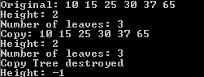

Programming Exercise

- Build the following binary tree:
50

30
80

10
60
120

100
130
20

- Write the FindSumVisitor class with 3 public methods: visit, getSum, and clearSum. A FindSumVisitor object sums all the nodes it visits.
- Print the tree in inorder using OutputVisitor, then print the sum of the entire tree using FindSumVisitor
- Print the left subtree of the root in inorder using OutputVisitor, then print the sum of the left subtree using FindSumVisitor
- Print the right subtree of the root in inorder using OutputVisitor, then print the sum of the right subtree using FindSumVisitor
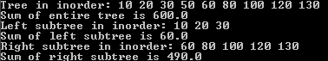

Note:
- When writing class FindSumVisitor, you do not need to parameterize it. It can implement Visitor<Integer>. However, then FindSumVisitor cannot be used to find the sum of a tree with doubles. Thus, class FindSumVisitor should implement Visitor<Number>. Recall that class Number is an abstract superclass for the numeric wrapper classes. It defines doubleValue() as an abstract method which all numeric wrapper classes support.

Hand in/email:
- BTree.java, which contains 2 classes, BTree and FindSumVisitor.

